**Collider Mechatronics Interview Assignment**

# Z-Height Control System

**Restraint:** Needed to source a motor that could lift 10lbs. axially with 0.1mm increments.

**Solution/Reasoning:** Chose a NEMA 23 with a threaded rod that can handle much higher weight than needed. (overdesigned on purpose as I’ve used the smaller NEMA 11’s/14’s/17’s which are designated to move >10lbs. but generally present great difficulty in current adjustment in order for it to work with good acceleration and holding torque.) Actual choice from **ThomsonLinear** shown below.

**Estimated Cost = $50-75. Can’t find actual cost – would call sales rep but distributors closed on weekend**

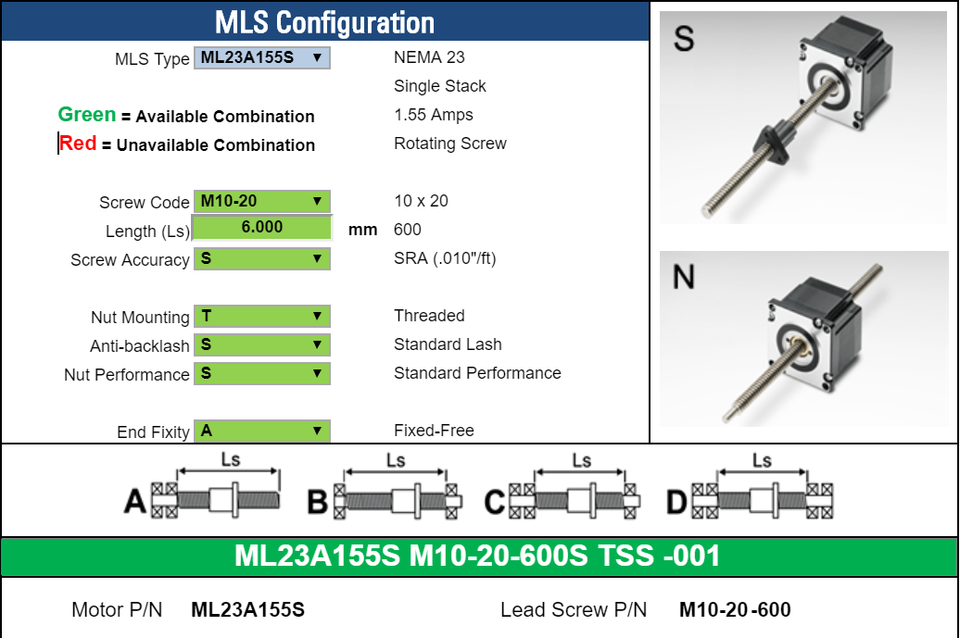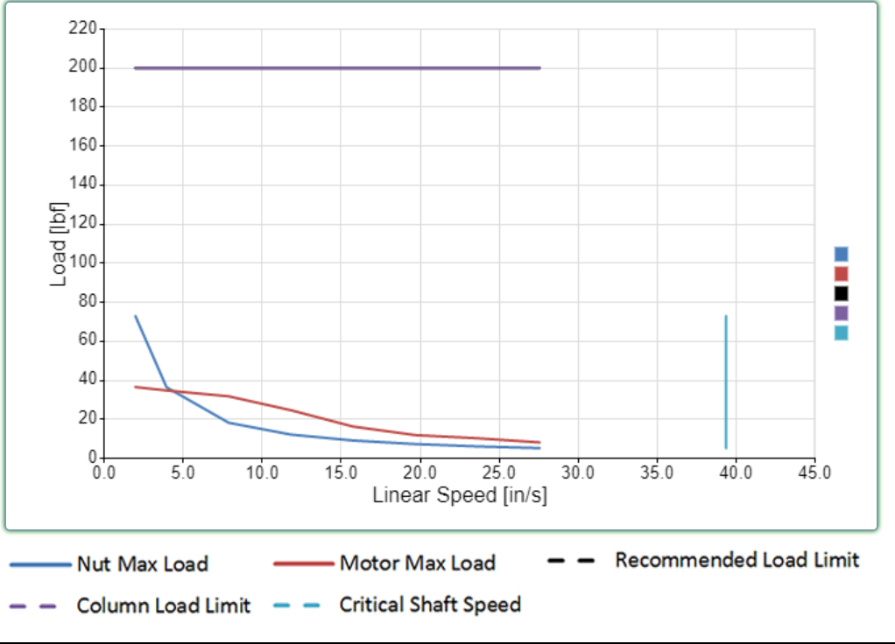

# Encoder

Found the AS5030 magnetic rotary encoder. Looking for either a development board or COTS that uses similar encoder in order to eliminate the need for PCB development. Mechaduino has an option, but they’re a small-scale startup that may not be able to source the quantities we need. Looking for consistency, so I will continue to look for a “built” solution using this or similar magnetic rotary encoder.

**Price – $7.4/piece Datasheet in Github folder.**

**Open source driver and encoder - http://tropical-labs.com/index.php/product/mechaduino-0-2-pcb**

# CAD/Mechanical Design

Created a quick and dirty design of what I’m thinking for mechanical. **I know they make similar items that are made and will work great, but cost is much higher.** This model is to prove the point, not create full functionality. Ideally, we’d source a COTS part, or if we needed to make one it would have better bracing and rigidity. Probably more slides/guide rails.

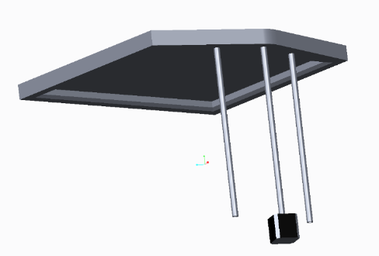

Motor in the center with a threaded rod, and two guide rails on either side. **Commercial version shown below.** This was on Alibaba for ~$300, no encoder and my experience with Alibaba has been poor. I bet we can find one that meet our specs for a decent price, will take a little time and searching.

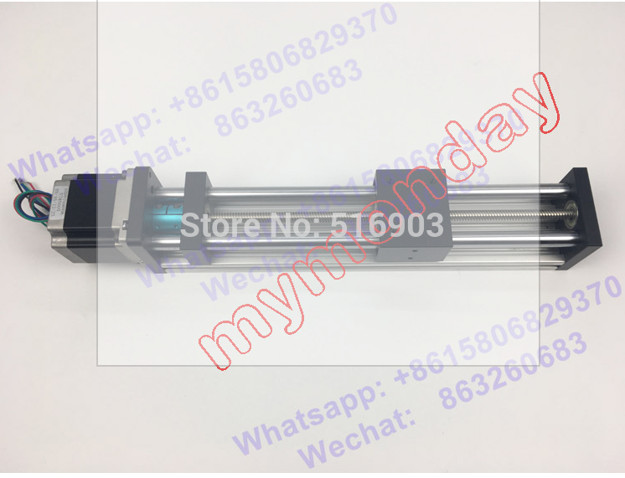

# Controller

I’d pick with a RedBearLabs CC3200 or Particle photon to run this. Both are essentially WiFi connected Arduino compatible controllers that have a ton of documentation. I’d then create a small web browser based control with a couple buttons to move motor up/down by certain amount. This would connect to the stepper through an A4988 Stepstick Stepper Motor Driver Module. This gives us the option of micro stepping if we want. This is something I’ve worked with before, they’re robust, easy and inexpensive. In a perfect world, I’d get to play with a driver that had a digital potentiometer to control the motor current more accurately. This would make it easier for mass production. But for the sake of time and proof of concept, the A4988 has a ton of code/documentation written already for reference and ease of use. Below is the wiring that would take place.

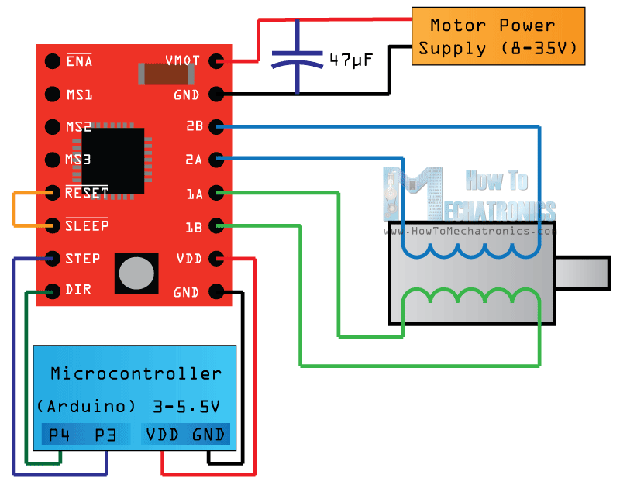

# Code

See the Github folder for commented code.